
“Seafood… like you have never seen before”

Catch up with the changes within the Victorian Seafood Industry and how these will affect your business. Learn about the opportunities and network with suppliers, buyers, end-users and government agencies while you enjoy a terrific seafood lunch – see, eat, learn about sustainable resources.

To be held at Kooyong Lawn Tennis Club, Executive Chef Kevin Ley will prepare an innovative 5 entrée course meal using established and non conventional seafood ingredients.

Key note speakers will include the Honourable Bob Cameron, Minister for Agriculture and Brian Casey, Chief Executive PrimeSafe, the statutory authority responsible for maintaining Victoria's reputation as a producer of clean, safe and fresh seafood.

When: Monday 1st September
Where: Kooyong Lawn Tennis Club
489 Glenferrie Road Kooyong (Mel Ref 59 C3)
Time: 11.30am for pre-luncheon drinks and networking
1st course will be served at 12pm SHARP

Cost: $60 for members ($75 non-members) inc GST
Phone: 9654 5866
Fax: 9654 5286
Post: PO Box 18193 Collins Street East, MELBOURNE VIC 8003
Email: rcav@restaurantcatervic.asn.au

RSVP essential by Wednesday 18 August 2003.

A joint initiative of the partners in Victorian Seafood and Restaurant & Catering Victoria

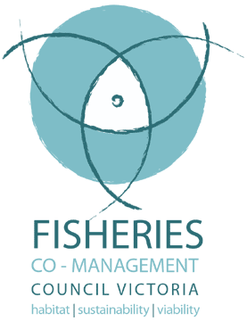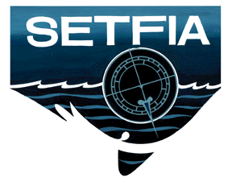

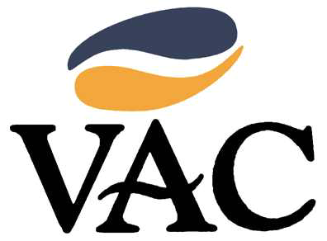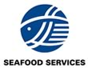



“Seafood… like you have never seen before”

I/We would love to attend “Seafood… like you have never seen before”

Please reserve ______ places

Name/s:
Organisation:
Member of:
Contact No:
Address:
Enclosed is my Cheque for $ made payable to Restaurant & Catering Victoria

Or Please charge my credit card $ AMEX Visa MasterCard □ Diners

Card Name:
Card Number: |  | Exp | /
Signature
Restaurant & Catering Victoria
PO Box 18193 Collins Street East, Melbourne VIC 8003
Ph (03) 9654 5866 Fax (03) 9654 5286
Email rcav@restaurantcatervic.asn.au

A joint initiative of the partners in Victorian Seafood and Restaurant & Catering Victoria

